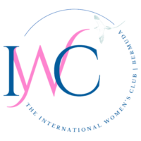
January 30, 2026

REQUEST FOR GRANT PROPOSALS 2026

The International Women’s Club of Bermuda (IWC) is pleased to announce its 2026 grant cycle!

For several decades, the IWC has been in a position to offer grants to Bermuda-registered nonprofit organizations. The one-time grants range in size from $2,500 to $10,000. This year’s grant making priorities will focus on organizations that offer programs supporting children & families, education, and health.

Last year’s grantees included Peak Potential ($7,500), Bermuda Autism Support and Education - BASE ($5000), and Saving Children and Revealing Secrets – SCARS ($5,000). In addition to grant funding, the grantees gain visibility through traditional and social media coverage, as well as increased awareness throughout the IWC membership.

Organizations should make a case for support of their organization and may request funds for general operations or for a specific program. The grant application should include as much detail as possible about the program(s) being supported and how funds will be used. Applicants should be in good financial standing with the ability to provide a board-approved budget and recently audited financial statements.

The grant application period is now open and will conclude on February 27. In general, grant applicants are invited to apply by current IWC members; however, qualified nonprofits may also self-nominate. Grant awards are announced in May and awarded in June. Please contact Jennifer Bull, IWC Philanthropy Chair at philanthropy@iwcbda.com to obtain application materials or if you have additional questions.

We look forward to hearing from you and to supporting your important community work!

Founded in 1981, International Women’s Club is a charitable social club for women in Bermuda, offering activities, support, and community engagement.

